|  |
| --- |
| [Type the company name] |
| Installing .NET Framework 4.0 |
| Windows server 2008 R2 Standard-64bit |

|  |
| --- |
|  |

# Installing Microsoft .NET Framework 4.0 (Standalone Installer)

* 1. Download Microsoft **.NET** Framework **4.0 (Standalone Installer)**

Click on the below URL

<http://www.microsoft.com/download/en/details.aspx?displaylang=en&id=17718>

* 1. Click on **“DOWNLOAD”**

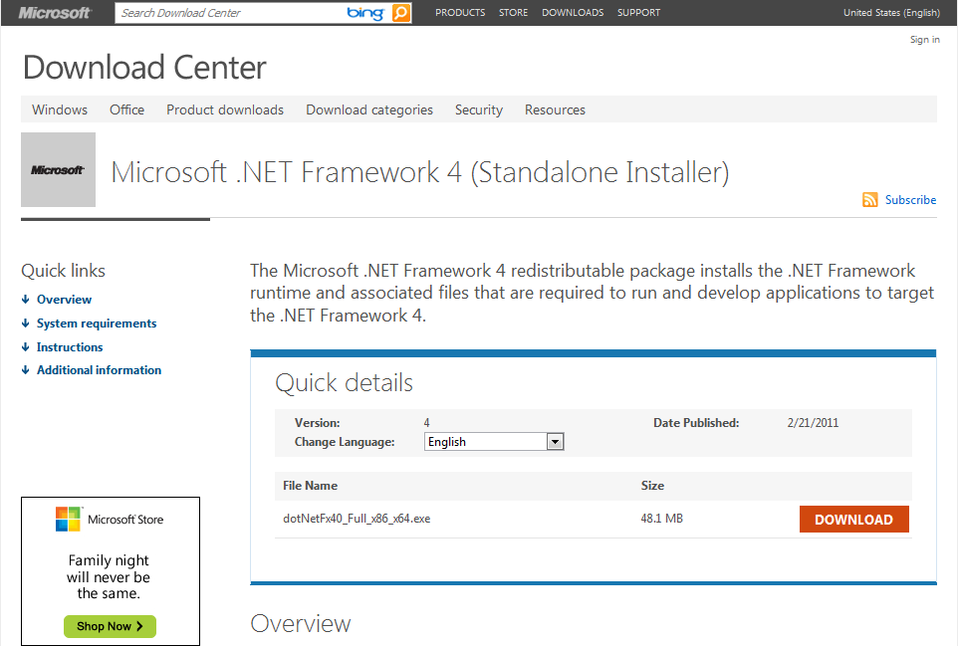

Figure : Download

* 1. Double Click **“DotNetFx40 Full x86 x64.exe”**

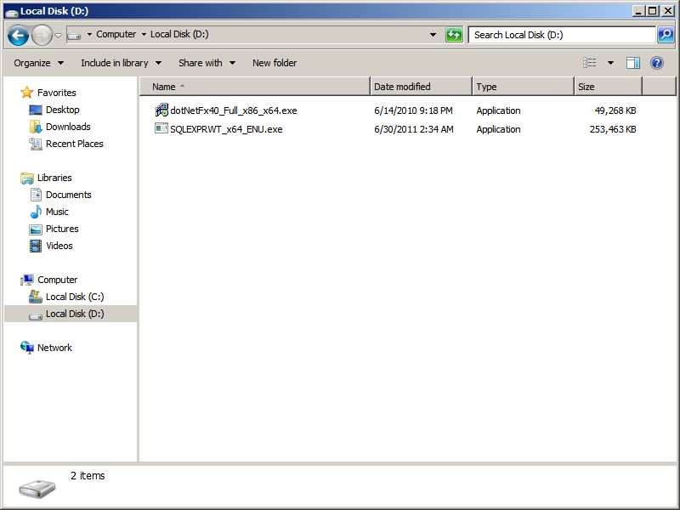

Figure : dotNetFx40_Full_x86_x64.exe

* 1. Click **“Run”**

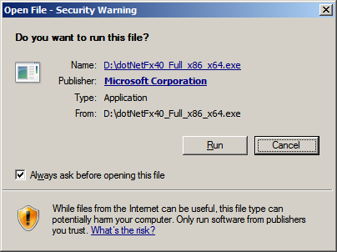

Figure : Open file

* 1. Extracting Files

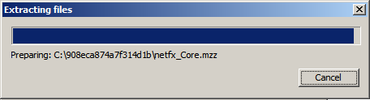

Figure : Extracting Files

* 1. Select **“I have read and Accept the license terms”** Check box
  2. Click **“Install”**

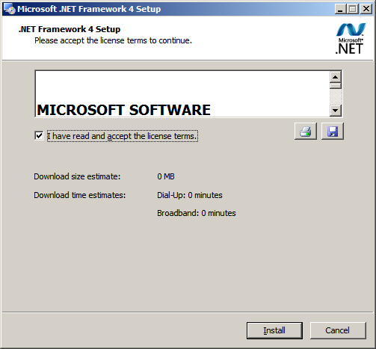

Figure : .NET Framework 4 Setup

* 1. Installation Progress

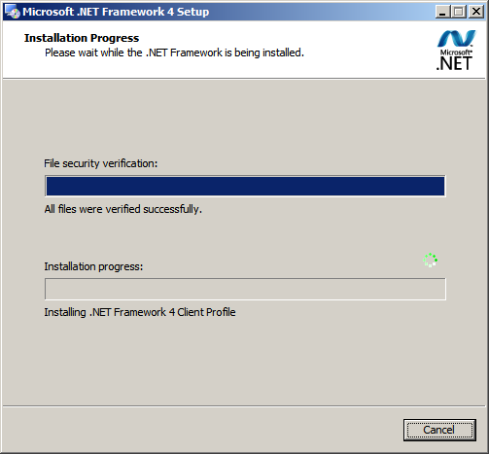

Figure : Installation Progress

* 1. Click **“Finish”**

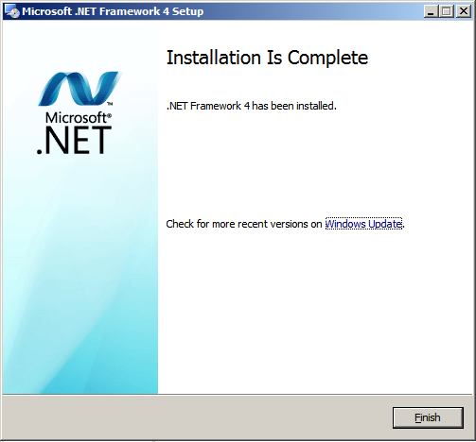

Figure : Microsoft .NET Framework 4 Setup